# 

# CRANFIELD GEOLOGICAL SERVICES INTERNATIONAL PTY LTD

**ACN – 606856320; ABN – 226068566320**

**30/01/2018**

**TO AUSTRAL Bricks**

**TAX INVOICE (registered for GST)**

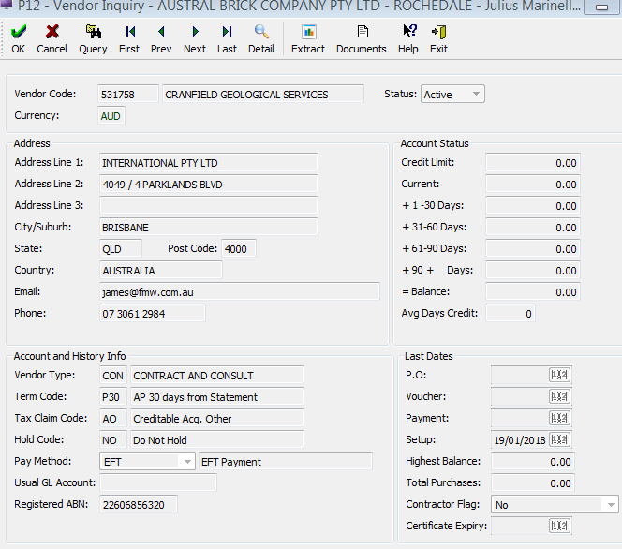

**Vendor number for Austral 531758**

**Work carried out at 19 January 2018 to -30 January 2018 and Prior to 19 January 2018 on a fixed price consultancy for 8 days at $1200 per day**

The schedule for this consultancy comprised:

* work on accessing data from open file publications on industrial roack and minerals and mineral occurrence and geological maps covering the Gympie, Brisbane Ipswich and Tweed Heads 1:250 000 map sheet areas covering an area south to the Queensland – New South Wales border and north to Kingaroy.
* The interpretation also generated likely sites for sample collection for consideration of long term clay resources in deeply weathered area to the west and north of Brisbane.
* Assessment of existing resources of the Ipswich Coal Measures and Woogaroo Subgroup indicates that most easily accessible resources occur under existing mining leases occur in the Bundamba Anticline region and north Ipswich area in RA 384.
* The assessment of areas to consider for new resources was undertaken using Queensland Globe resource layers and the QDEX system of the Department of Natural Resources and Mines.
* Overall the contract took more than 12 working days from mid – December 2017 to date (30 January 2018) of which only 8 working days have been billed in this invoice.

**Total Hours 8 days at $1200 per day rate**

**Sub Total =$9,600, GST = $960;**

**Total cost incl GST = $10,560**

**Total - $10,560**